User Manual
How to install the SpecterX Chrome Extension



Install SpecterX Chrome extension
- Go to the chrome web store using this link: https://chrome.google.com/webstore/detail/specterx-secure-collabora/oflpjpejdompcdnhnijoenebhgndjkkd?hl=en&authuser=0

- Click “Add to Chrome”
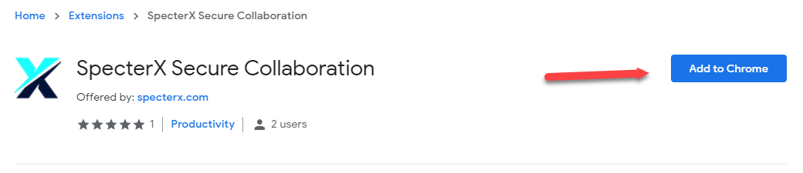
- Click “Add extension”
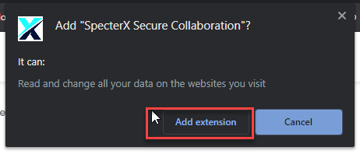
In case you previously installed an old version of the extension, click “Enable this item” and then you will be allowed to remove it and add the extension’s new version.
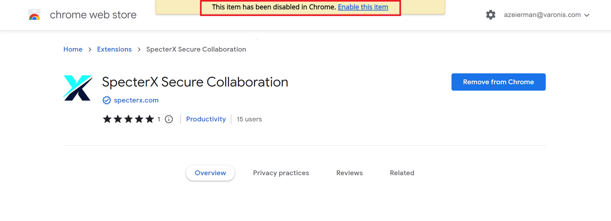

Pin extension to navigation bar (optional)
- Click on the “Puzzle” icon next to the address bar, search for “SpecterX Secure Collaboration” and click the pin icon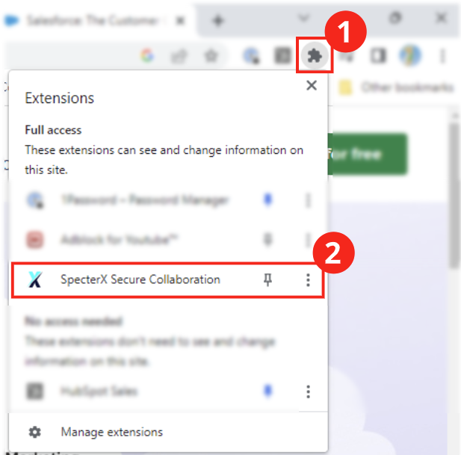
- If pinned successfully, it will look like this

Login to SpecterX extension
- Log into your salesforce account
- Click on the SpecterX icon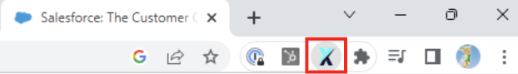

- Log into SpecterX using your Okta account (it may take a minute)
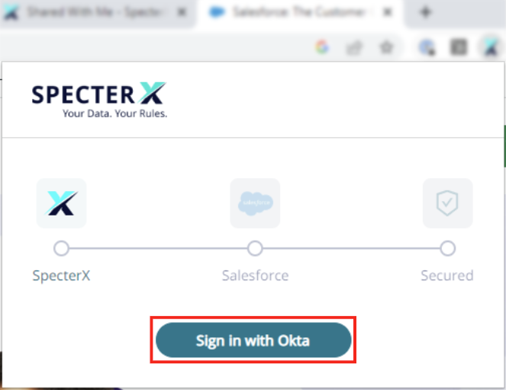

- If everything went well, you will be logged into the extension and see your latest activities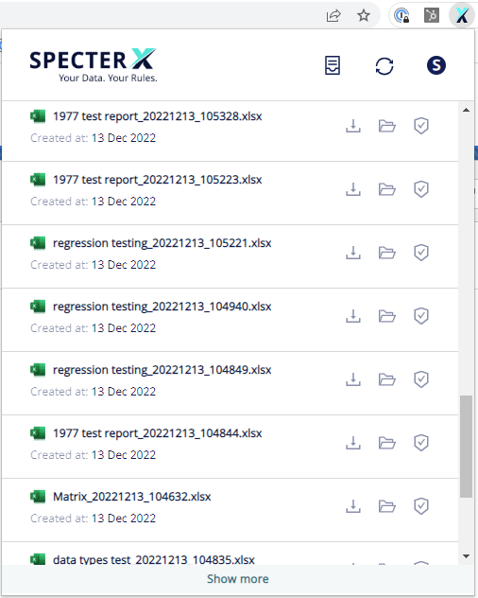
If you are a new user, you will see this message:


Exporting a report
- Log into your Salesforce account
- Select a report you would like to export
- On the right-hand side, click on the Edit drop-down arrow and select Save and Export
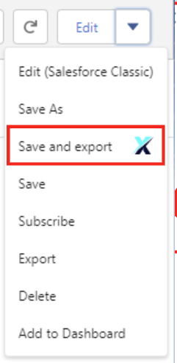

- Select your preferred export view and click Export
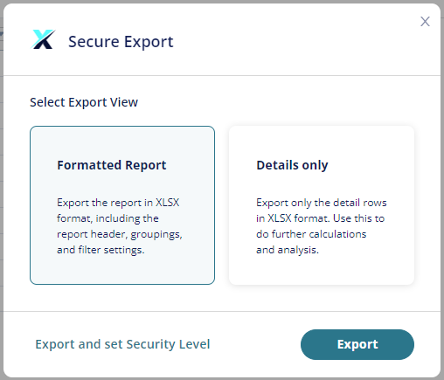

You can also set the report’s security level by clicking Export and set security level

- Your exported report will be saved in your local Downloads folder and will be displayed in the extension window and in the “My files” page in the SpecterX app.
- In case you choose to open the report with Microsoft Excel Online, you will be required to confirm that you are using SpecterX - Click “Accept”